GUÍA N° 5 SEGUNDO AÑO MEDIO INGLÉS

Nombre:__________________________________________Fecha:_______________________

Objetivo: to develop activities related to vocabulary about Globalization.

Estimada familia:
Si no cuenta con los textos escolares, podrá visualizarlo y descargarlo desde el sitio: www.aprendoenlinea.mineduc.cl/

Con el fin de apoyar el aprendizaje, puede ver los siguientes videos, en la medida de sus posibilidades:
www.youtube.com

Todas las dudas enviarlas al correo de la profesor/a:

Para realizar esta guía debes apoyarte en tu texto escolar en las siguientes páginas:

I. - Choose and underline five items from the box that you think are the most important to be a global city. (Escoge y subraya 5 ítems desde el recuadro que tu creas que son los más importantes en una cuidad global)

HIGH QUALITY MEANS OF TRANSPORT – FAMOUS FOOTBALL TEAM – BIG AIRPORT – OPERA HOUSE – HEADQUARTERS OF MULTINATIONAL CORPORATIONS – MANY FAST-FOOD RESTAURANTS – FINANCIAL CENTERS – UNIVERSITIES – ADVANCED COMMUNICATION INFRASTRUCTURES - HIGHWAYS

II.- Write a list from 1 to 5 in order of importance for you .(Escribe una lista de 1 al 5 en orden de importancia para ti de acuerdo a lo que subrayaste en el ejercicio anterior).

1.___________________________________________________________________________________

2.___________________________________________________________________________________

3. __________________________________________________________________________________

4. __________________________________________________________________________________

5. __________________________________________________________________________________

III. - Read the texts (I – II) about two global cities and identify which cities they are. (Leer los textos sobre dos cuidades globales e identifica qué cuidades son)
- Match the texts with a picture (1 – 2).( Unir los textos con la imágen que corresponda)

- Then, write the name of each city above the corresponding picture.(después escribe el nombre de cada cuidad debajo de cada imagen)

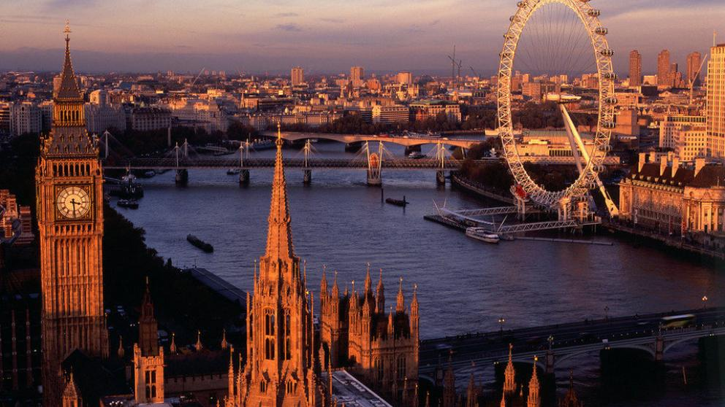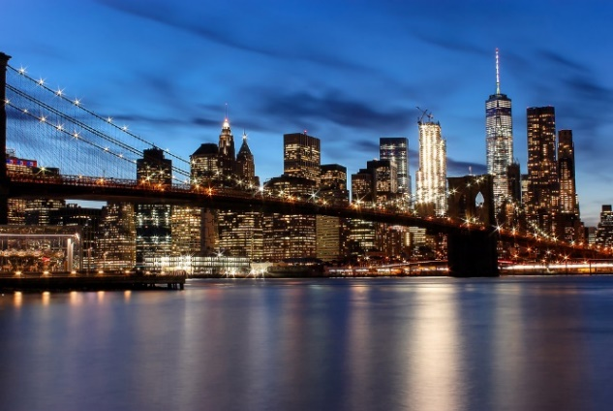
____ ____________________________________ ______________________________________________
I. It has a population of more than 12,5 million and it is one of the most populated cities of the world. Around 35 million people live in metropolitan area. It is also one of the most expensive cities of the world and one of the most powerful cities for the world’s economy. It has a lot of banks, headquarters of important global companies and huge shopping centers. Its Stock Exchange is the second largest in the world.
The city has two main airports: Narita and Haneda. There are a few and very beautiful parks. The biggest one is East Garden, near the Imperial Palace.

II. It is the capital of England and the United Kingdom and the most populated urban area in Europe. The city has around 7,5 million inhabitants, but 12 million live in surrounding area.
It is home of the headquarters of the largest global companies and it has one of the most important financial centers around the world. There are many historic buildings in the downtown area, and it has the oldest and most extensive subway network in the world.
The city has a variety of people, culture and religions and it offers a lot of cultural and entertainment activities.
It has four airports: Heathrow, Gatwick, Stansted, and Lutton.
There are many parks; the biggest one is very famous and is called Hyde Park.

Estimados alumn@s

Esperando que todos y todas se encuentren bien, recuerden que el desarrollo de esta guía lo deben enviar al mail en inglés y español en la medida que puedan, y además de tener el desarrollo de esta en su cuaderno .No olviden que pueden enviar sus consultas o dudas al mail: anaastudilloicp@gmail.com

Se despide atte
Miss Ana Astudillo C

